SQL MANAGEMENT SYSTEM SCHEMA

TITLE -> CODING PLATFORM SYSTEM

* This system allows users to login into and solve coding problems

responsibilities of a user include :-
1. login into system
2. edit profile of the existing user
3. write solutions to a coding problem
4. like or dislike a given problem
5. create a coding problem and post into the system

creation of a problem includes :-
1. title of the problem
2. description of the problem, which inturn renders HTML code
3. including tags to the created problem
4. writing test cases, where these test cases will be used to judge whether a solution is accepted or not
5. including hints to the created problem

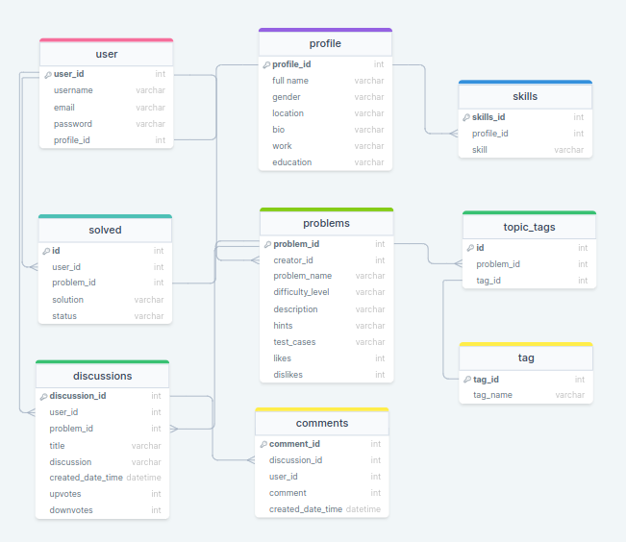
tables explaination :-

USER TABLE
1. user table is self explaintory, it consists of a foreign key relating to the profile table
2. each user has a unique profile id

PROFILE TABLE
1. every user has a unique profile id
2. this table consists of personal details of a particular user
3. each and every user/profile can have multiple skills, so i have one to many relationship here using a seperate skills table

SKILL TABLE
1. this table contains skills for a particular profile, so this has a one-to-one ralationship with profile table

SOLVED TABLE
1. this table consists of all the submitted solutions, whether are accepted or wrong solutions
2. user_id, problem_id, solution and status of that submitted is seen here

PROBLEMS TABLE
1. this table consists of all the created problems
2. problems are created by users itself, so i have used one-to-many relationship with the user table. created problems can have any number problem_tags and can also be included in many problems, so here i used many-to-many relationship with tags table

TAGS TABLE
1. this table consists of problem tags like greedy, linkedlist, etc...

TOPIC_TAGS
1. this table acts as a junction between problems table and tags table inorder to maintain many-to-many relationship between them

DISCUSSIONS TABLE
1. this table contains discussions to a particular problem
2. this is a separate table which which contains user_id, problem_id as well as discussion
3. this has one-to-many relationship to the comments table, as one discussion can have multiple comments

COMMENTS TABLE
1. this table stores comments to a particular thread/discussion created by a particular user
2. this is linked to discussions table by one-to-many relationship

